

American International University-Bangladesh (AIUB)  
**Department of Computer Science  
Faculty of Science &Technology (FST)  
Summer 22 23**

**Courier Management Service**

Software Requirement Engineering

Sec: **E**

Project submitted

By

Faizur Rahman (20-43701-2)

Md. Sabit Hasan (20-43703-2)

Md. Ashraful Islam Emad (20-43710-2)

**Table of Context**

1. PROBLEM DOMAIN.............................................................................................................3-4
   1. Background to the Problem............................................................................................................... 3
   2. Solution to the Problem....................................................................................................................3-4
2. SOLUTION DESCRIPTION............................................................................................... 5-13
   1. System Features...................................................................................................................5-8
   2. UML Diagram …………………………………………………………………………8-10
   3. User interface……………………………………………………………………….10-13
3. SOCIAL IMPACT .............................................................................................................14
4. DEVELOPMENT PLAN……................................................................................................ 14
5. PROJECT SCHEDULE........................................................................................................ 15
6. MARKETING PLAN............................................................................................................16
7. COST & PROFIT ANALYSIS ............................................................................................. 17
8. .REFRENCES.......................................................................................................................18

1. **PROBLEM DOMAIN**
   1. **Background to the Problem**

* A Courier Service Management System is specialized software that courier companies to efficiently handle their package delivery operations. This system provides a centralized platform to store, track, and monitor the movement of parcels, enabling efficient operations and exceptional customer service. This system keeps track of all the packages, their destinations, and their delivery status. It helps in organizing routes for delivery drivers, scheduling pickups, and providing real-time updates to customers about where their packages are and when they'll arrive. It allows the company to store information about all branches and use this data when setting the destination for parcel pickups. It is very difficult to do this process manually. Hence it is recommended to computerize the process by developing the relative database as the world is turning into information and technology; computerization becomes a necessity in all walks of life. In essence, the system aims to streamline the entire courier process, making it more organized, reliable, and customer friendly.
* The root cause of the problem that necessitates a Courier Service Management System often lies in the complex and dynamic nature of modern courier services. As the volume of shipments and deliveries increases, manual management becomes prone to errors, delays, and inefficiencies. The absence of a centralized system can lead to miscommunication, missed deadlines, poor resource allocation, and dissatisfied customers. These challenges are compounded by the need for accurate tracking, timely updates, and effective route planning, which are difficult to achieve without a dedicated software solution. The problem of managing courier services effectively is crucial to address because it directly impacts the overall success and reputation of the courier company. Inefficient operations can lead to increased operational costs, lost revenue opportunities, customer complaints, and damaged brand image. Customers today expect transparency, prompt deliveries, and reliable tracking, making it imperative for courier services to adapt and provide a seamless experience. A Courier Service Management System addresses these issues by automating processes, optimizing routes, enabling real-time tracking, and ensuring timely communication, ultimately enhancing operational efficiency and customer satisfaction.
  1. **Solution to the Problem**
* The Courier Management System will aim to achieve the following objectives and why this solution is particularly appropriate to solve the problem:
* Streamlined Courier Operations: Automate the process of managing courier bookings, tracking deliveries, and generating reports to improve operational efficiency. The automation of various courier management tasks will significantly enhance operational efficiency. This streamlining of processes will save time, reduce human error, and improve overall productivity.
* Role-Based Access: Provide separate user roles for staff members and administrators to ensure appropriate access and control over the system's functionalities. Implementing role-based access ensures appropriate levels of control and security. Staff members can focus on their tasks, while administrators maintain oversight and control over the system.
* Tracking: Enable staff members and customers to track courier packages in real-time, providing accurate delivery status updates. The real-time tracking feature for staff members and customers ensures accurate visibility into the status of courier packages. This transparency builds trust, enhances customer satisfaction, and enables proactive issue resolution.
* **User-Centric Interface:** The user-friendly interface catering to both administrators and customers ensures a smooth and intuitive experience. This approach promotes adoption and minimizes the learning curve for all stakeholders involved.
* Reporting: Generate reports on courier performance, delivery trends, customer feedback, and operational insights for better decision-making. The reporting capabilities of the CMS, which provide insights into courier performance, delivery trends, customer feedback, and operational metrics, empower administrators to make informed decisions for continuous improvement.

While the proposed solution appears feasible, it's important to note that successful implementation depends on several factors, including the technical expertise of the development team, proper planning, thorough testing, and adequate resources. Additionally, the solution's effectiveness in meeting the business objectives may also depend on factors such as user adoption, integration with existing systems, and ongoing support and maintenance. Before moving forward, it's recommended to conduct a detailed feasibility analysis, including a technical assessment, cost analysis, and a review of potential challenges. This will help ensure that the solution is not only feasible on paper but also in practice, and that it aligns with the specific needs and constraints of the business.

* The primary objective of this project is to develop a Courier Management System (CMS) that provides an efficient and effective solution for managing courier operations. The CMS will offer a user-friendly interface for both courier company administrators and customers to streamline the process of courier delivery and tracking. The system's objectives align directly with the needs of the business and its stakeholders.

1. **SOLUTION DESCRIPTION**
   1. **System Features**

**Common Feature:**

**System Feature: Home Page:**

**Functional Requirements:**

1. The home page should provide users with an overview of the Courier Service Management System.
2. The home page should allow users to navigate to different sections of the website.
3. The home page should include a search function that allows users to find Courier Service Management by location.

**Quality Attributes:**

1. Usability: The home page should be easy to navigate and provide users with the information they need quickly and efficiently.
2. Reliability: The home page should be stable and available to users at all times.
3. Performance: The home page should load quickly and respond to user actions promptly.
4. Security: The home page should protect user data and ensure the privacy and security of sensitive information.
5. Accessibility: The home page should be accessible to users with disabilities, including those who use assistive technology.
6. Scalability: The home page should be able to handle a large number of users and display information in real-time.

**System Feature: Login**

**Functional Requirements:**

1. Allow users (admin and staff) to log in to their account using their email address or user name and password or social media credentials.
2. Allow users to reset their password in case they forget it.

**Quality Attributes:**

1. Usability: The login system must be user-friendly and easy to navigate for users of all technical backgrounds.
2. Security: The login system must ensure the confidentiality and integrity of user credentials and prevent unauthorized access to user accounts.
3. Performance: The login system must be fast and responsive to provide a seamless user experience.
4. Accessibility: The login system must be accessible to users with disabilities or special needs.

**System Feature: Track Parcel**

**Functional Requirements:**

1. The system should be able to track all parcel’s activities.
2. The system should be able to track the location of delivered parcel in real-time.
3. The system should be able to track the status of customer parcel, from pickup to delivery.
4. The system should be able to generate reports on financial and others.

**Quality Attributes:**

1. Usability: The tracking function should be easy to use for staff, admin and users, with clear instructions and an intuitive interface.
2. Reliability: The tracking function should provide accurate and up-to-date information on employee location and order status.
3. Performance: The tracking function should be fast and efficient, with minimal loading times for tracking information and notifications.
4. Security: The tracking function should ensure the privacy and security of customer and employee data.
5. Scalability: The tracking function should be able to handle a large number of tracking requests and provide information in real-time.

**System Feature: Update Delivery Status**

**Functional Requirements:**

1. The system should allow to update the status of the delivery, such as "en route", "delivered", or "failed to deliver".
2. The system should allow the customer to check updates of their parcel status in real-time.
3. The system should allow the office employee to view the updated delivery status and take appropriate actions if necessary.
4. The system should keep a record of all delivery status updates for future reference and analysis.

**Quality Attributes:**

1. Usability: The update delivery status function should be easy to use and require minimal effort from the delivery person.
2. Reliability: The system should ensure that the updated delivery status is accurate and reflected in real-time for the customer and office employee.
3. Performance: The update delivery status function should be fast and efficient, with minimal loading times.
4. Security: The system should ensure the privacy and security of customer data and delivery information.
5. Scalability: The system should be able to handle a large number of delivery status updates in real-time.

**System Feature: Take Parcel Order**

**Functional Requirements:**

1. The system should allow input and submit orders to the courier service.
2. The system should allow the delivery person to view the status of their submitted orders.

**Quality Attributes:**

1. Usability: The system should be easy to use for both staff and admin in the management.
2. Reliability: The system should accurately record and manage the orders received from delivery.
3. Performance: The system should be fast and efficient, with minimal lag times between order submission and acceptance.
4. Security: The system should ensure the privacy and security of all order information and transaction details.
5. Scalability: The system should be able to handle a large volume of orders from multiple delivery persons simultaneously.

# Admin:

**System Feature: Manage Branches and staff’s**

**Functional Requirements:**

1. The system should allow the admin to view all branches and staffs.
2. The system should display details of each branches and staffs.
3. The system should allow the office employee to filter and sort orders based on various criteria, such as joining date, branch code, and customer name.
4. The system should allow the admin to make changes in branches and manage staffs like adding new branches or staff.

**Quality Attributes:**

1. Usability: The system should provide an easy-to-use interface for viewing and managing orders.
2. Reliability: The system should display accurate and up-to-date information about each order and its status.
3. Performance: The system should be fast and efficient, with minimal loading times for order details and search results.
4. Security: The system should ensure the privacy and security of customer and laundry service provider data.
5. Scalability: The system should be able to handle a large number of orders and display order details in real-time.
   1. **UML Diagrams**

**Class Diagram:**

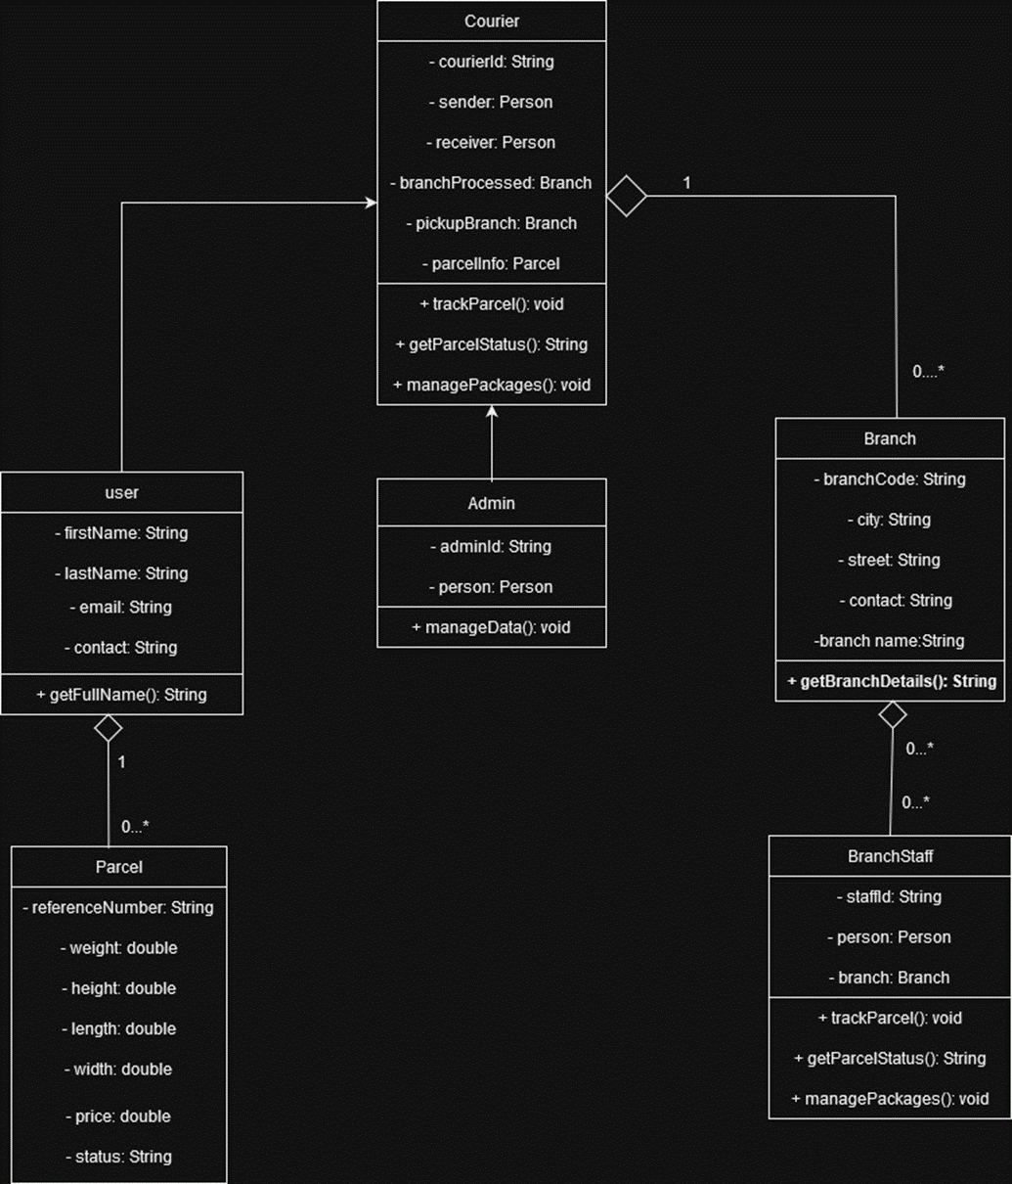

# Use Case Diagram:

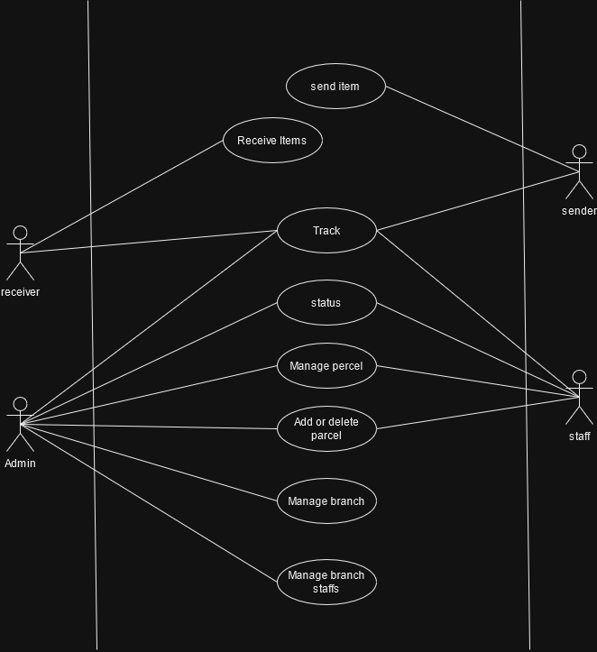

# Activity Diagram:

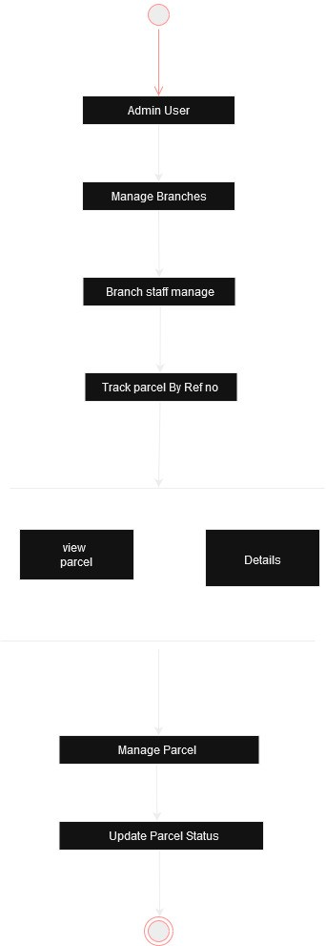

* 1. **User interface:**

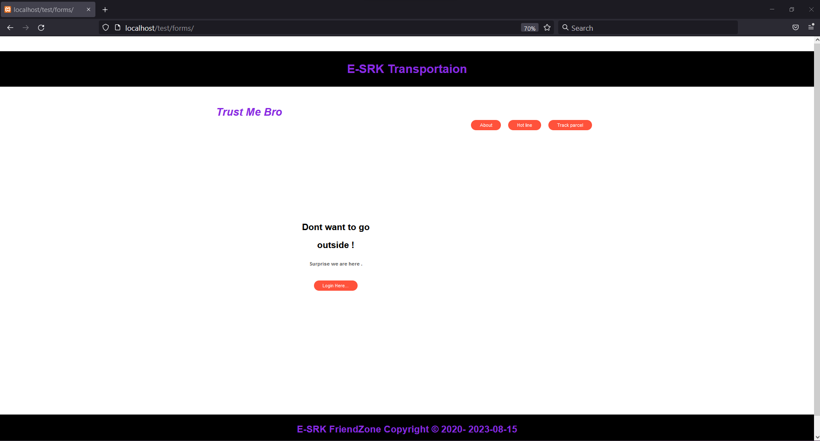

**Figure 1: Index page**

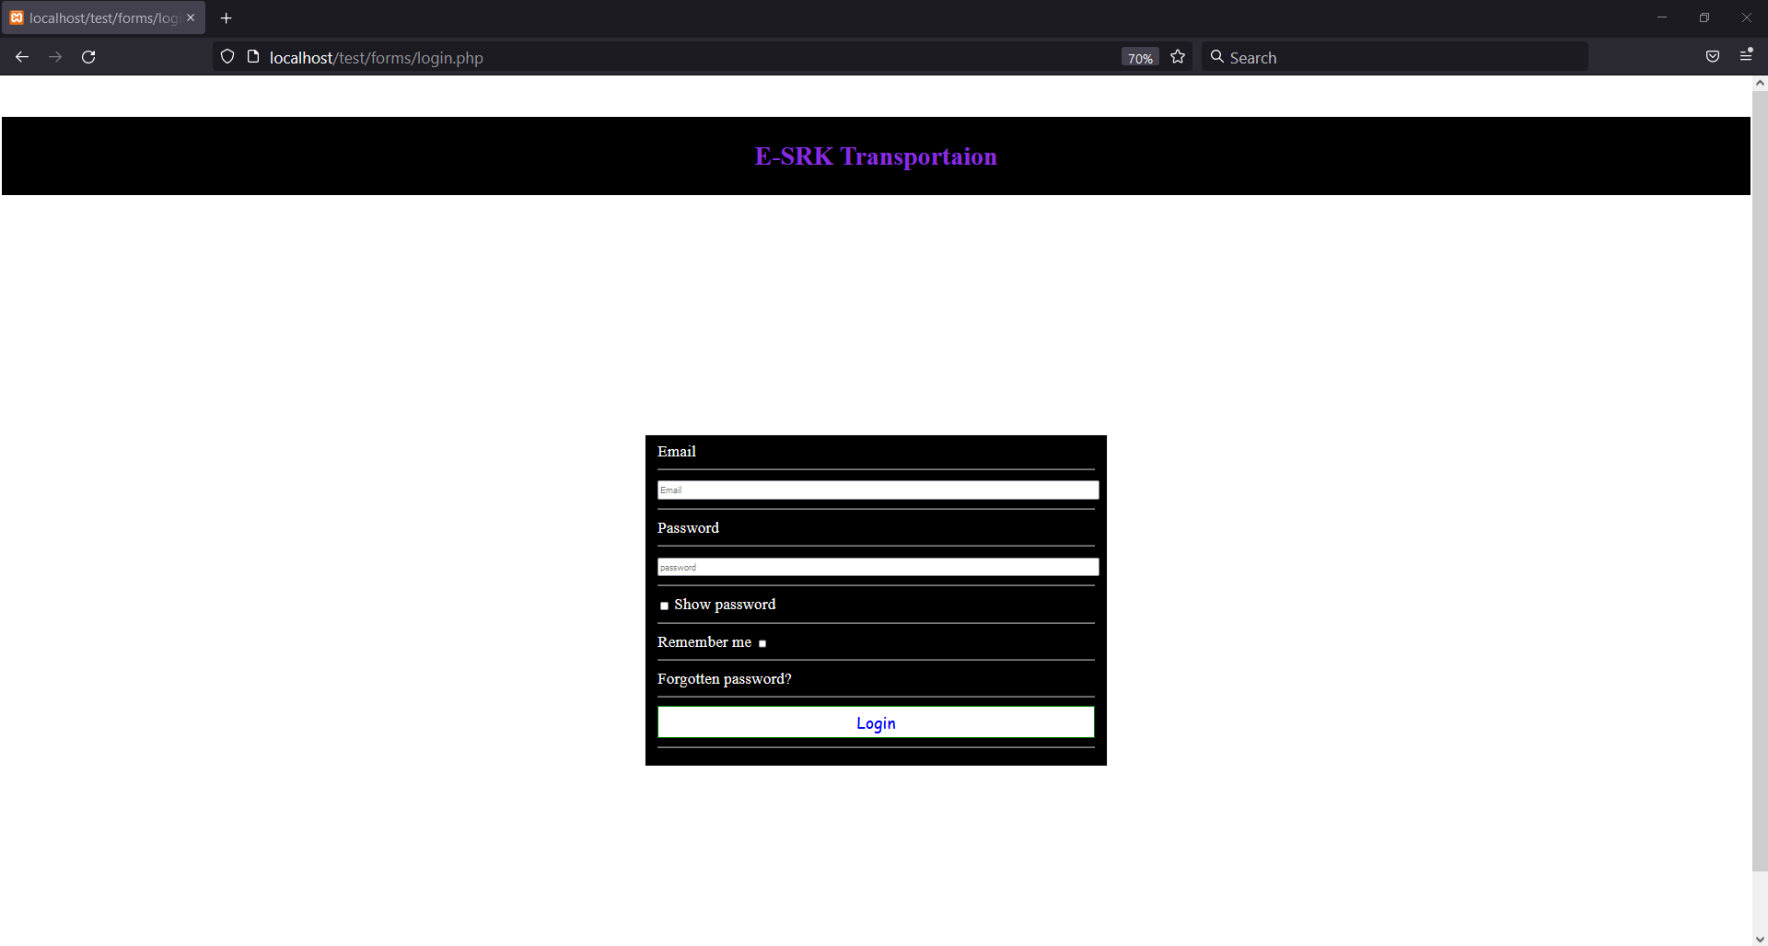

**Figure 2: Login Page**

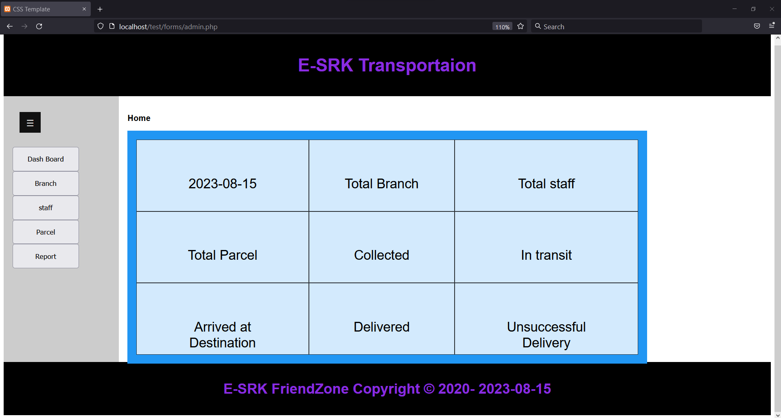

**Figure 3: Admin Panel**

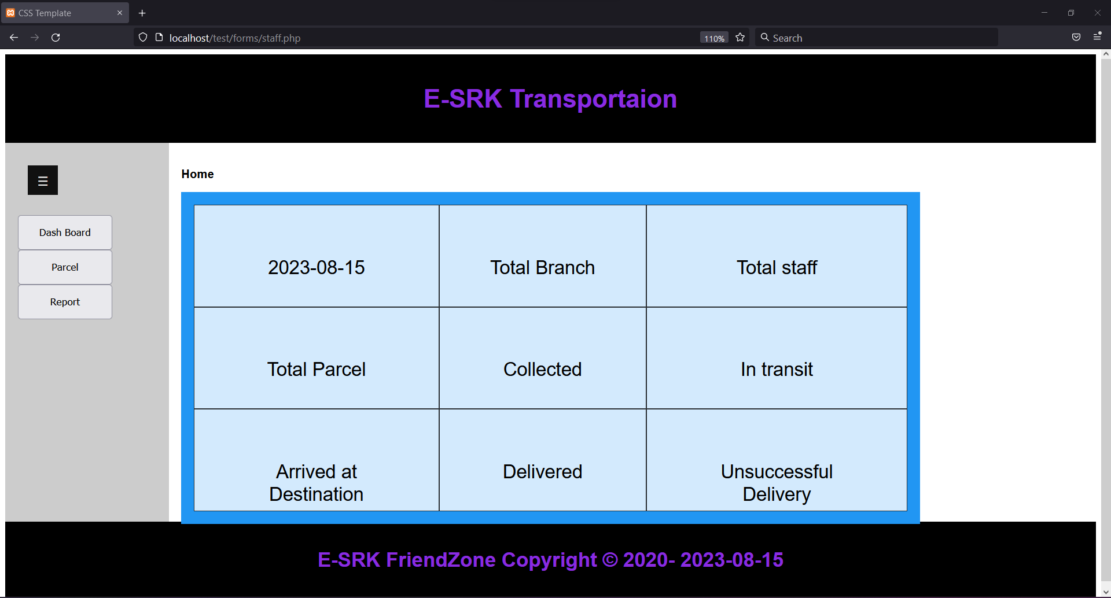

**Figure 4: Staff Panel**

1. **Social Impact**

The Courier Service Management System aims to bring several benefits to society by optimizing courier operations and enhancing the overall efficiency of the delivery process. The Courier Service Management System offers a streamlined approach to managing courier operations. By automating tasks such as booking management, package tracking, and reporting, the system reduces the reliance on manual processes. This leads to increased operational efficiency, shorter delivery times, and reduced instances of human error. With real-time tracking capabilities, both staff members and customers gain accurate visibility into the status and location of courier packages. This transparency promotes trust and reliability in the delivery process. Customers can track their shipments in real-time, leading to improved customer satisfaction. Additionally, staff members can proactively address any issues that may arise during the delivery, resulting in quicker problem resolution. The system's user-centric interface ensures that all stakeholders, including administrators, staff members, and customers, can easily navigate and utilize the platform. This intuitive experience minimizes the learning curve and encourages widespread adoption, benefiting users of varying technological expertise. The reporting features of the Courier Service Management System provide valuable insights into courier performance, delivery trends, customer feedback, and operational metrics. Administrators can make informed decisions based on these insights, leading to continuous improvement in service quality and operational effectiveness. Overall, the implementation of the Courier Service Management System enhances the efficiency, transparency, and reliability of courier services. This contributes to improved customer satisfaction, reduced operational inefficiencies, and a more seamless and trustworthy delivery experience for society.

1. **Development Plan with Project Schedule**

Outlining a development plan for a Courier Service Management System involves various stages of the Software Development Life Cycle (SDLC). Projects contain deadlines, spending limits, and specifications that must be met. The project plan is created using agile project planning. Agile project management is made to be adaptable enough to handle tasks that could potentially move, change, or evolve. An agile team can clearly see the objectives of their project thanks to agile planning. Here's a high-level overview of the development plan, along with a basic project schedule:

**1. Requirements Gathering and Analysis:**

* Understand the client's needs and goals for the Courier Service Management System.
* Define detailed requirements, features, and functionalities of the system.
* Identify potential challenges and constraints.

**2. System Design:**

* Create a system architecture and design that addresses the requirements.
* Design the user interface, database structure, and system modules.
* Plan the integration of third-party APIs (if required).

**3. Development:**

* Develop the system components according to the design.
* Implement automation for courier bookings, real-time tracking, role-based access, reporting, and other features.
* Conduct regular code reviews and testing to ensure quality.

**4. Testing:**

* Perform unit testing to verify individual components.
* Conduct integration testing to ensure smooth communication between modules.
* Perform user acceptance testing (UAT) with real users to validate functionality.

**5. Deployment:**

* Prepare the system for deployment to production environment.
* Set up servers, databases, and other infrastructure.
* Configure security measures to protect user data and system integrity.

**6. Training and Documentation:**

* Provide training to staff members and administrators on how to use the system.
* Create user documentation and guides for all functionalities.

**7. Launch and Monitoring:**

* Deploy the system to production and make it accessible to users.
* Monitor system performance, stability, and user engagement.
* Address any issues or bugs that may arise after deployment.

**8. Maintenance and Updates:**

* Continuously monitor system performance and user feedback.
* Plan and implement regular updates, bug fixes, and feature enhancements.
* Ensure data backups and disaster recovery procedures are in place.

**Project Schedule:**

Planning Phase: Weeks 1-3

Requirements and feasibility Analysis Phase: Weeks 3-4

Design Phase: Weeks 4-6

Development Phase: Weeks 7-8

Testing Phase: Weeks 9

Deployment Phase: Weeks 10

Marketing Phase: Weeks 11-12

Maintenance Phase: Weeks 13-15

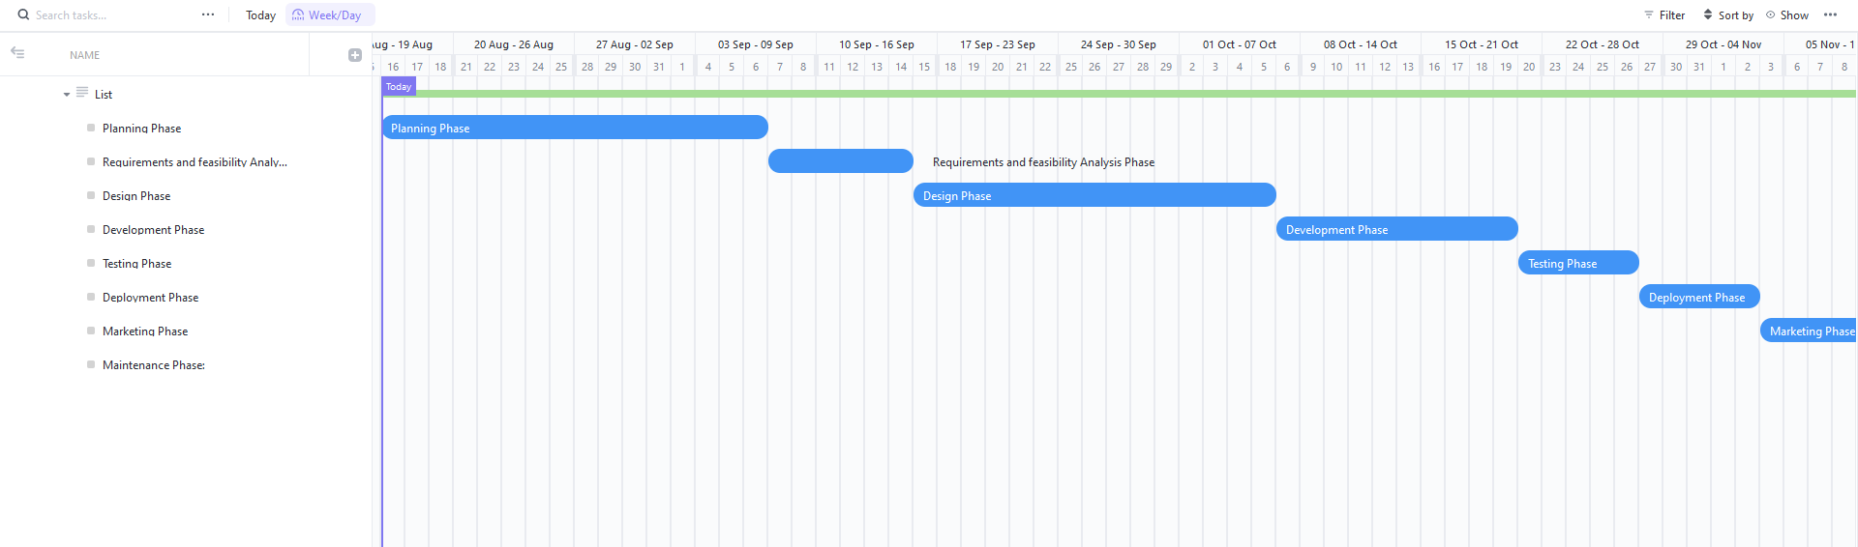

**Figure 1: The total Gantt for the Project**

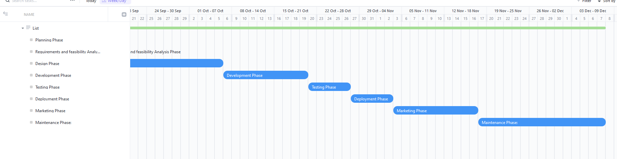

**Figure 2: The total Gantt for the Project**

1. **Marketing Plan**

Certainly, developing a marketing plan for a Courier Service Management System involves strategies for both the short term and long term. Here's a breakdown of marketing strategies for both timeframes:

**Short-Term Marketing Plan:**

1.Awareness Campaign:

- Launch social media campaigns highlighting the benefits of the Courier Service Management System.

- Create engaging posts, videos, and infographics that showcase its key features.

- Utilize targeted advertising to reach potential customers.

2. Partnerships and Collaborations:

- Collaborate with local courier companies for cross-promotion.

- Offer special incentives for early adopters and partners to encourage adoption.

3. Limited-Time Offers:

- Introduce limited-time discounts or free trials for new customers.

- Encourage users to experience the benefits of the system firsthand.

4. Press Releases and Blog Posts:

- Issue press releases announcing the launch of the Courier Service Management System.

- Publish blog posts explaining the system's value proposition and features.

5. Email Campaigns:

- Send targeted email campaigns to existing customers and leads.

- Include compelling content and clear calls-to-action.

**Long-Term Marketing Plan:**

1. Content Marketing:

- Create and share informative articles, case studies, and whitepapers.

- Establish your brand as an industry thought leader.

2. Customer Testimonials:

- Collect and showcase positive feedback and success stories from satisfied customers.

- Highlight how the system has improved their courier operations.

3. Search Engine Optimization (SEO):

- Optimize our website and content to rank higher on search engines.

- Use relevant keywords and phrases related to courier management systems.

4. Webinars and Workshops:

- Continue hosting webinars and workshops to educate prospects about the system's capabilities.

- Invite industry experts to provide insights on logistics and delivery management.

5. Community Engagement:

- Participate in industry events, conferences, and trade shows.

- Network with potential clients- and showcase your solution.

6. Referral Program:

- Introduce a referral program where existing customers can refer new clients in exchange for rewards.

- Leverage the power of word-of-mouth marketing.

7. Continuous Updates:

- Regularly release updates and enhancements to the system's features.

- Communicate these updates through newsletters and blog posts.

Remember that both short-term and long-term marketing strategies should be adaptable based on market trends, customer feedback, and competition. Regularly analyze the effectiveness of our marketing efforts and adjust our strategies as needed to achieve the best results.

1. **Cost and Profit Analysis**

**Cost:**

1.System Developer: One system developer is required to develop the Courier Service Management System Website. They should have specialized knowledge in programming languages, such as HTML, PHP, Java Script and CSS as well as experience in developing website.

2. Database Administrator: One database administrator is needed to manage and optimize the database used by the website. He should be proficient in database technologies such as SQL and Oracle and should have experience in developing database architectures.

3. Quality Assurance Engineer: One quality assurance engineer is necessary to ensure the quality of the application. They should have experience in testing and debugging website and should be capable of executing various test cases.

4. UI/UX Designers: One UI/UX designers are required to design the user interface of the website. They should have experience in designing graphical elements and creating interactive user interfaces.

5. Project Manager: One project manager is needed to coordinate the development and implementation of the CMS website. They should have experience in managing software development projects and should be capable of leading a team of developers.

**Efficient budget use:** A marketing budget details how much money a company plans to spend over a quarter or year on marketing efforts. Paid advertising, sponsored site content, additional marketing personnel, a registered blog.

Development: 20000 BDT

Design: 15000 BDT

Marketing & Advertising: 10000 BDT

Miscellaneous Expenses: 5000 BDT

Total Budget: 50000 BDT

**Profit:**

Those who will or which company are interested to buy our website for their startup courier service business we will charge them about 80000 BDT at 1 time buy. We are assuming at least 10 companies will buy our website per month.

So, Our Total Budget = 50000 BDT

Selling Cost = 80000 BDT

At 1 time sell profit = (80000-50000) = 30000 BDT

Expected Selling = 10

At 10 times sell profit = (30000*10) = 300000 BDT

1. **Reference**
   1. <https://mydhl.express.dhl/bd/en/home.html#/>
   2. <https://www.sundarbancourierltd.com/>
   3. <http://www.gatewayexpress.com.bd/>
   4. <https://www.dexi.com.bd/>
   5. <https://usbexpress.com/branches.php>